12576 – Nisanth Saravanan
L1. NET Technologies(.NET & C#)- Intermediate Assessments

Multi-language Translation Microservice

a. Translates text between languages. It supports batch and real-time translation and is
used in applications requiring multilingual support for content or communication.

b. APIs are designed to be integrated into an API Gateway for centralized access and
routing.

POST /translate – Translate text
GET /languages – List supported languages
POST /translate/batch – Translate multiple texts

c. In micro services following services could be implemented as separate Web-API to
implement Web-API-Gateway.
LanguageDetectionService
TranslationEngineService
GlossaryManagementService

Task:

1. Perform W3H analysis on the given Case Study.
2. Use the Case Study and Create WEB-API to implement Code-First Approach.
3. Generate an OpenAPI (Swagger) specification, API Gateway routing config, Next
implement microservice architecture.
4. Perform validations in each model using Data Annotations.
5. Use ASP.Net Entity Framework Core for Back-End Communication.
6. Use MySQL as your database.
7. Use ReactJS as Front-End Application Development.
8. Apply style using CSS / Bootstrap.
9. Perform CRUD operations.
10. Maintain Code Quality and Coding Standard.

W3H Analysis

Project Title: Multi-language Translation Microservice
What? |  | How?
1. What are the module needed for this project?  A: Modules Required:  - LanguageDetectionService.  - TranslationEngineService.  - GlossaryManagementService.  - Front-End UI.  2. What are the features of LanguageDetectionService?  A: LanguageDetectionService:  - Need API testing Capabilities.  - Implement API Methods.  - Supports CRUD via a front-end.  3. What are the features of TranslationEngineService?  A: TranslationEngineService:  - Need API testing Capabilities.  - Implement API Methods.  - Supports CRUD via a front-end.  4. What are the features of GlossaryManagementService?  A: GlossaryManagementService:  - Need API testing Capabilities.  - Implement API Methods.  - Supports CRUD via a front-end.  5. What are the features of the Front-End UI?  A: Front-End UI:  - Supports CRUD operations with the services.  - Have ease of access to identify and perform data actions. |  | 1. LanguageDetectionService:  - Need API testing Capabilities:  - Method 1: Use Swagger UI.  - Method 2: Use Postman.  - Method 3: Use Manual API calls via CLI.  - Implement API Methods:  - Method 1: Use Controllers only.  - Method 2: Use Repositories.  - Method 3: Use Service + Repositories.  - Supports CRUD via a front-end:  - Method 1: Use HTTP.  - Method 2: Use HTTPS.  - Method 3: Use a common Gateway on either HTTP or HTTPS.  2. TranslationEngineService:  - Need API testing Capabilities:  - Method 1: Use Swagger UI.  - Method 2: Use Postman.  - Method 3: Use Manual API calls via CLI.  - Implement API Methods:  - Method 1: Use Controllers only.  - Method 2: Use Repositories.  - Method 3: Use Service + Repositories.  - Supports CRUD via a front-end:  - Method 1: Use HTTP.  - Method 2: Use HTTPS.  - Method 3: Use a common Gateway on either HTTP or HTTPS.  3. GlossaryManagementService:  - Need API testing Capabilities:  - Method 1: Use Swagger UI.  - Method 2: Use Postman.  - Method 3: Use Manual API calls via CLI.  - Implement API Methods:  - Method 1: Use Controllers only.  - Method 2: Use Repositories.  - Method 3: Use Service + Repositories.  - Supports CRUD via a front-end:  - Method 1: Use HTTP.  - Method 2: Use HTTPS.  - Method 3: Use a common Gateway on either HTTP or HTTPS.  4. Front-End UI:  - Supports CRUD operations with the services:  - Method 1: Use simple forms.  - Method 2: Use JSON data as input.  - Method 3: Simply redirect to Postman.  - Have ease of access to identify and perform data actions:  - Method 1: Colour Code the buttons.  - Method 2: Hovering with always show detailed explanation of the button.  - Method 3: Add accessibility tools.
1. LanguageDetectionService:  - Need API testing Capabilities:  - Method 2: Use Postman.  A: Highly efficient with proper UI support to test and document APIs.  - Implement API Methods:  - Method 1: Use Controllers only.  A: Simple and efficient implementation methodology for a smaller version of this case.  - Supports CRUD via a front-end:  - Method 3: Use a common Gateway on either HTTP or HTTPS.  A: Supports multiple APIs at once in an effective manner.  2. TranslationEngineService:  - Need API testing Capabilities:  - Method 2: Use Postman.  A: Highly efficient with proper UI support to test and document APIs.  - Implement API Methods:  - Method 1: Use Controllers only.  A: Simple and efficient implementation methodology for a smaller version of this case.  - Supports CRUD via a front-end:  - Method 3: Use a common Gateway on either HTTP or HTTPS.  A: Supports multiple APIs at once in an effective manner.  3. GlossaryManagementService:  - Need API testing Capabilities:  - Method 2: Use Postman.  A: Highly efficient with proper UI support to test and document APIs.  - Implement API Methods:  - Method 1: Use Controllers only.  A: Simple and efficient implementation methodology for a smaller version of this case.  - Supports CRUD via a front-end:  - Method 3: Use a common Gateway on either HTTP or HTTPS.  A: Supports multiple APIs at once in an effective manner.  4. Front-End UI:  - Supports CRUD operations with the services:  - Method 1: Use simple forms.  A: Efficient and Simple to implement/  - Have ease of access to identify and perform data actions:  - Method 1: Colour Code the buttons.  A: Easier solution to address the issue. |  | 1. LanguageDetectionService:  - Need API testing Capabilities:  - Method 1: Use Swagger UI.  - Method 3: Use Manual API calls via CLI.  A: In-efficient and may cause errors if middle ware configuration is not don’t correctly.  - Implement API Methods:  - Method 2: Use Repositories.  - Method 3: Use Service + Repositories.  A: Too complex for a small scale prototype.  - Supports CRUD via a front-end:  - Method 1: Use HTTP.  - Method 2: Use HTTPS.  A: Does the job but due to existence of multiple APIs, this alone cant suffice.  2. TranslationEngineService:  - Need API testing Capabilities:  - Method 1: Use Swagger UI.  - Method 3: Use Manual API calls via CLI.  A: In-efficient and may cause errors if middle ware configuration is not don’t correctly.  - Implement API Methods:  - Method 2: Use Repositories.  - Method 3: Use Service + Repositories.  A: Too complex for a small scale prototype.  - Supports CRUD via a front-end:  - Method 1: Use HTTP.  - Method 2: Use HTTPS.  A: Does the job but due to existence of multiple APIs, this alone cant suffice.  3. GlossaryManagementService:  - Need API testing Capabilities:  - Method 1: Use Swagger UI.  - Method 3: Use Manual API calls via CLI.  A: In-efficient and may cause errors if middle ware configuration is not don’t correctly.  - Implement API Methods:  - Method 2: Use Repositories.  - Method 3: Use Service + Repositories.  A: Too complex for a small scale prototype.  - Supports CRUD via a front-end:  - Method 1: Use HTTP.  - Method 2: Use HTTPS.  A: Does the job but due to existence of multiple APIs, this alone cant suffice.  4. Front-End UI:  - Supports CRUD operations with the services:  - Method 2: Use JSON data as input.  - Method 3: Simply redirect to Postman.  A: Highly roundabout methodologies that don’t promise efficient results.  - Have ease of access to identify and perform data actions:  - Method 2: Hovering with always show detailed explanation of the button.  - Method 3: Add accessibility tools.  A: Highly roundabout methodologies that don’t promise efficient results.
Why? |  | Why Not?

CODE

All APIs Have Common Program.cs

//Program.cs

using Microsoft.EntityFrameworkCore;
using TranslationEngineService.Data;

var builder = WebApplication.CreateBuilder(args);

// Add services to the container.
builder.Services.AddControllers();

// Learn more about configuring Swagger/OpenAPI at https://aka.ms/aspnetcore/swashbuckle
builder.Services.AddEndpointsApiExplorer();

builder.Services.AddDbContext<AppDbContext>(options => options.UseMySql(builder.Configuration.GetConnectionString("DefaultConnection"),
ServerVersion.AutoDetect(builder.Configuration.GetConnectionString("DefaultConnection"))));

// Add CORS policy
builder.Services.AddCors(options =>
{
options.AddPolicy("AllowLocalhostFrontend", policy =>
{
policy.WithOrigins("http://localhost:63399")
.AllowAnyHeader()
.AllowAnyMethod();
});
});

var app = builder.Build();

app.UseCors("AllowLocalhostFrontend");
app.UseHttpsRedirection();
app.UseAuthorization();
app.MapControllers();
app.Run();

TranslationEngineService

Model

using System.ComponentModel.DataAnnotations;

namespace TranslationEngineService.Model
{
public class TranslationEngine
{
[Key]
public int Id { get; set; }

public string TranslationString { get; set; }

public string FromLang { get; set; }

public string ToLang { get; set; }
}
}

Data

//AppDbContext.cs

using Microsoft.EntityFrameworkCore;
using TranslationEngineService.Model;

namespace TranslationEngineService.Data

{
public class AppDbContext : DbContext
{
public AppDbContext(DbContextOptions<AppDbContext> options) : base(options) { }

public DbSet<TranslationEngine> TranslationEngines{ get; set; }
}
}

Controller

//Controller.cs

using Microsoft.AspNetCore.Mvc;
using Microsoft.EntityFrameworkCore;
using TranslationEngineService.Data;
using TranslationEngineService.Model;

namespace TranslationEngineService.Controllers
{
[Route("api/[controller]")]
[ApiController]
public class TranslationEngineController : ControllerBase
{
private readonly AppDbContext _Context;

public TranslationEngineController(AppDbContext context)
{
_Context = context;
}

//Get: api/
[HttpGet]
public async Task<IActionResult> GetAll()
{
var students = await _Context.TranslationEngines.ToListAsync();
return Ok(students);
}

[HttpGet("{id}")]
public async Task<IActionResult> Get(int id)
{
var translationItem = await _Context.TranslationEngines.FindAsync(id);
if (translationItem == null) return NotFound();
else return Ok(translationItem);
}

[HttpPost]
public async Task<IActionResult> Create([FromBody] TranslationEngine translationItem)
{
_Context.TranslationEngines.Add(translationItem);
await _Context.SaveChangesAsync();
return CreatedAtAction(nameof(Create), translationItem);
}

[HttpPut("{id}")]
public async Task<IActionResult> Update(int id, [FromBody] TranslationEngine translationItem)
{
var translationItemToUpdate = await _Context.TranslationEngines.FindAsync(id);
if (translationItemToUpdate == null) return NotFound();
translationItemToUpdate.TranslationString = translationItem.TranslationString;
await _Context.SaveChangesAsync();
return NoContent();
}

[HttpDelete("{id}")]
public async Task<IActionResult> Delete(int id)
{
var student = await _Context.TranslationEngines.FindAsync(id);
if (student == null) return NotFound();
_Context.TranslationEngines.Remove(student);
await _Context.SaveChangesAsync();
return NoContent();
}
}
}

appsettings.json

{
"Logging": {
"LogLevel": {
"Default": "Information",
"Microsoft.AspNetCore": "Warning"
}
},
"ConnectionStrings": {
"DefaultConnection": "Server=127.0.0.1;Port=3306;Database=TranslationEngineServiceDB;User=root;Password=root"
},
"AllowedHosts": "*"
}

GlossaryManagementService

Model

using System.ComponentModel.DataAnnotations;

namespace GlossaryManagementService.Model
{
public class GlossaryManagement
{
[Key]
public int Id { get; set; }

public string Word { get; set; }

public string Meaning { get; set; }

public string? Notes { get; set; }
}
}

Data

//AppDbContext.cs

using Microsoft.EntityFrameworkCore;
using GlossaryManagementService.Model;

namespace GlossaryManagementService.Data

{
public class AppDbContext : DbContext
{
public AppDbContext(DbContextOptions<AppDbContext> options) : base(options) { }

public DbSet<GlossaryManagement> GlossaryManagements { get; set; }
}
}

Controller

//Controller.cs

using Microsoft.AspNetCore.Mvc;
using Microsoft.EntityFrameworkCore;
using GlossaryManagementService.Data;
using GlossaryManagementService.Model;

namespace GlossaryManagementService.Controllers
{
[Route("api/[controller]")]
[ApiController]
public class GlossaryManagementController : ControllerBase
{
private readonly AppDbContext _Context;

public GlossaryManagementController(AppDbContext context)
{
_Context = context;
}

//Get: api/
[HttpGet]
public async Task<IActionResult> GetAll()
{
var glosssaryItems = await _Context.GlossaryManagements.ToListAsync();
return Ok(glosssaryItems);
}

[HttpGet("{id}")]
public async Task<IActionResult> Get(int id)
{
var glosssaryItem = await _Context.GlossaryManagements.FindAsync(id);
if (glosssaryItem == null) return NotFound();
else return Ok(glosssaryItem);
}

[HttpPost]
public async Task<IActionResult> Create([FromBody] GlossaryManagement glosssaryItem)
{
_Context.GlossaryManagements.Add(glosssaryItem);
await _Context.SaveChangesAsync();
return CreatedAtAction(nameof(Create), glosssaryItem);
}

[HttpPut("{id}")]
public async Task<IActionResult> Update(int id, [FromBody] GlossaryManagement glosssaryItem)
{
var glosssaryItemToUpdate = await _Context.GlossaryManagements.FindAsync(id);
if (glosssaryItemToUpdate == null) return NotFound();
glosssaryItemToUpdate.Word = glosssaryItem.Word;
glosssaryItemToUpdate.Meaning = glosssaryItem.Meaning;
glosssaryItemToUpdate.Notes = glosssaryItem.Notes;
await _Context.SaveChangesAsync();
return NoContent();
}

[HttpDelete("{id}")]
public async Task<IActionResult> Delete(int id)
{
var glosssaryItem = await _Context.GlossaryManagements.FindAsync(id);
if (glosssaryItem == null) return NotFound();
_Context.GlossaryManagements.Remove(glosssaryItem);
await _Context.SaveChangesAsync();
return NoContent();
}
}
}

appsettings.json

{
"Logging": {
"LogLevel": {
"Default": "Information",
"Microsoft.AspNetCore": "Warning"
}
},
"ConnectionStrings": {
"DefaultConnection": "Server=127.0.0.1;Port=3306;Database=GlossaryManagementServiceDB;User=root;Password=root"
},
"AllowedHosts": "*"
}

LanguageDetectionService

Model

using System.ComponentModel.DataAnnotations;

namespace LanguageDetectionService.Model
{
public class LanguageDetection
{
[Key]
public int Id { get; set; }

public string Name { get; set; }

public string? Origin { get; set; }

public string? Notes { get; set; }
}
}

Data

//AppDbContext.cs

using Microsoft.EntityFrameworkCore;
using LanguageDetectionService.Model;

namespace LanguageDetectionService.Data

{
public class AppDbContext : DbContext
{
public AppDbContext(DbContextOptions<AppDbContext> options) : base(options) { }

public DbSet<LanguageDetection> LanguageDetections { get; set; }
}
}

Controller

//Controller.cs

using Microsoft.AspNetCore.Mvc;
using Microsoft.EntityFrameworkCore;
using LanguageDetectionService.Data;
using LanguageDetectionService.Model;

namespace LanguageDetectionService.Controllers
{
[Route("api/[controller]")]
[ApiController]
public class LanguageDetectionController : ControllerBase
{
private readonly AppDbContext _Context;

public LanguageDetectionController(AppDbContext context)
{
_Context = context;
}

//Get: api/
[HttpGet]
public async Task<IActionResult> GetAll()
{
var languageItems = await _Context.LanguageDetections.ToListAsync();
return Ok(languageItems);
}

[HttpGet("{id}")]
public async Task<IActionResult> Get(int id)
{
var languageItem = await _Context.LanguageDetections.FindAsync(id);
if (languageItem == null) return NotFound();
else return Ok(languageItem);
}

[HttpPost]
public async Task<IActionResult> Create([FromBody] LanguageDetection languageItem)
{
_Context.LanguageDetections.Add(languageItem);
await _Context.SaveChangesAsync();
return CreatedAtAction(nameof(Create), languageItem);
}

[HttpPut("{id}")]
public async Task<IActionResult> Update(int id, [FromBody] LanguageDetection languageItem)
{
var languageItemToUpdate = await _Context.LanguageDetections.FindAsync(id);
if (languageItemToUpdate == null) return NotFound();
languageItemToUpdate.Name = languageItem.Name;
languageItemToUpdate.Origin = languageItem.Origin;
languageItemToUpdate.Notes = languageItem.Notes;
await _Context.SaveChangesAsync();
return NoContent();
}

[HttpDelete("{id}")]
public async Task<IActionResult> Delete(int id)
{
var student = await _Context.LanguageDetections.FindAsync(id);
if (student == null) return NotFound();
_Context.LanguageDetections.Remove(student);
await _Context.SaveChangesAsync();
return NoContent();
}
}
}

appsettings.json

{
"Logging": {
"LogLevel": {
"Default": "Information",
"Microsoft.AspNetCore": "Warning"
}
},
"ConnectionStrings": {
"DefaultConnection": "Server=127.0.0.1;Port=3306;Database=LanguageDetectionServiceDB;User=root;Password=root"
},
"AllowedHosts": "*"
}

API Gateway

Program.cs

//Program.cs - Ocelot

using Ocelot.DependencyInjection;
using Ocelot.Middleware;

var builder = WebApplication.CreateBuilder(args);

// Add services to the container.
builder.Configuration.AddJsonFile("ocelot.json", optional: false, reloadOnChange: true);
builder.Services.AddOcelot();
builder.Services.AddControllers();

// Add CORS policy
builder.Services.AddCors(options =>
{
options.AddPolicy("AllowLocalhostFrontend", policy =>
{
policy.WithOrigins("http://localhost:63399")
.AllowAnyHeader()
.AllowAnyMethod();
});
});

var app = builder.Build();

app.UseCors("AllowLocalhostFrontend");

app.UseHttpsRedirection();
app.UseAuthorization();
app.MapControllers();
await app.UseOcelot();
app.Run();

Ocelot.json

//Ocelot.json

{
"Routes": [
{
"UpstreamPathTemplate": "/gateway/GlossaryManagement",
"UpstreamHttpMethod": [ "GET", "POST" ],
"DownstreamPathTemplate": "/api/GlossaryManagement",
"DownstreamScheme": "http",
"DownstreamHostAndPorts": [
{
"Host": "localhost",
"Port": 5276
}
]
},
{
"UpstreamPathTemplate": "/gateway/GlossaryManagement/{id}",
"UpstreamHttpMethod": [ "GET", "PUT", "DELETE" ],
"DownstreamPathTemplate": "/api/GlossaryManagement/{id}",
"DownstreamScheme": "http",
"DownstreamHostAndPorts": [
{
"Host": "localhost",
"Port": 5276
}
]
},
{
"UpstreamPathTemplate": "/gateway/LanguageDetection",
"UpstreamHttpMethod": [ "GET", "POST" ],
"DownstreamPathTemplate": "/api/LanguageDetection",
"DownstreamScheme": "http",
"DownstreamHostAndPorts": [
{
"Host": "localhost",
"Port": 5194
}
]
},
{
"UpstreamPathTemplate": "/gateway/LanguageDetection/{id}",
"UpstreamHttpMethod": [ "GET", "PUT", "DELETE" ],
"DownstreamPathTemplate": "/api/LanguageDetection/{id}",
"DownstreamScheme": "http",
"DownstreamHostAndPorts": [
{
"Host": "localhost",
"Port": 5194
}
]
},
{
"UpstreamPathTemplate": "/gateway/TranslationEngine",
"UpstreamHttpMethod": [ "GET", "POST" ],
"DownstreamPathTemplate": "/api/TranslationEngine",
"DownstreamScheme": "http",
"DownstreamHostAndPorts": [
{
"Host": "localhost",
"Port": 5233
}
]
},
{
"UpstreamPathTemplate": "/gateway/TranslationEngine/{id}",
"UpstreamHttpMethod": [ "GET", "PUT", "DELETE" ],
"DownstreamPathTemplate": "/api/TranslationEngine/{id}",
"DownstreamScheme": "http",
"DownstreamHostAndPorts": [
{
"Host": "localhost",
"Port": 5233
}
]
}
]
}

React Front-End Application

Components

//GlossaryForm.jsx

import React, { useState, useEffect } from 'react';

const GlossaryForm = ({ onSubmit, initial }) => {
const [form, setForm] = useState(initial);

useEffect(() => {
setForm(initial);
}, [initial]);

const handleSubmit = (e) => {
e.preventDefault();

if (form.notes == null || form.notes == "") {
form.notes = "No Notes."
}

onSubmit(form);
setForm({ word: '', meaning: '', notes: '' });
};

return (
<form onSubmit={handleSubmit}>
<table>
<tbody>
<tr>
<td>
<input
type="text"
placeholder="Enter the word."
value={form.word || ''}
onChange={(e) => setForm({ ...form, word: e.target.value })}
required
/>
</td>
</tr>
<tr>
<td>
<input
type="text"
placeholder="Enter the meaning."
value={form.meaning || ''}
onChange={(e) => setForm({ ...form, meaning: e.target.value })}
required
/>
</td>
</tr>
<tr>
<td>
<input
type="text"
placeholder="Any additional notes?"
value={form.notes || ''}
onChange={(e) => setForm({ ...form, notes: e.target.value })}
/>
</td>
</tr>
<tr>
<td>
<button type="submit">{initial.id ? 'Update' : 'Add'} Glossary</button>
</td>
</tr>
</tbody>
</table>
</form>
);
};

export default GlossaryForm;

//GlossaryList.jsx

import React, { useState } from 'react';

const GlossaryList = ({ glossaries, onEdit, onDelete }) => {
const [searchTerm, setSearchTerm] = useState('');

const handleSearch = () => {
const results = glossaries.filter(g =>
g.word.toLowerCase().includes(searchTerm.toLowerCase())
);
const message = results.length
? 'Search Results:\n' + results.map(g => `Word: ${g.word} \nMeaning: ${g.meaning} \nAdditional Notes: ${g.notes}`).join('\n')
: 'No matching glossaries found.';
alert(message);
};

if (!glossaries || glossaries.length === 0) {
return <p>No glossaries found.</p>;
}

return (
<>
<h2>Glossary Search:</h2>
<div style={{ marginBottom: '40px', display: "flex" }}>
<input
type="text"
placeholder="Enter the word."
value={searchTerm}
onChange={(e) => setSearchTerm(e.target.value)}
/>
<button onClick={handleSearch}>Search</button>
</div>

<h2>Glossary List</h2>
<table className="list" style={{ borderCollapse: 'collapse', width: '100%', marginBottom: '80px' }}>
<thead>
<tr>
<th>Word</th>
<th>Meaning</th>
<th>Additional Notes</th>
<th>Edit</th>
<th>Delete</th>
</tr>
</thead>
<tbody>
{glossaries.map((g) => (
<tr key={g.id}>
<td>{g.word}</td>
<td>{g.meaning}</td>
<td>{g.notes}</td>
<td>
<button onClick={() => onEdit(g)}>Edit</button>
</td>
<td>
<button onClick={() => onDelete(g.id)}>Delete</button>
</td>
</tr>
))}
</tbody>
</table>
</>
);
};

export default GlossaryList;

//LanguageForm.jsx

import React, { useState, useEffect } from 'react';

const LanguageForm = ({ onSubmit, initial }) => {
const [form, setForm] = useState(initial);

useEffect(() => {
setForm(initial);
}, [initial]);

const handleSubmit = (e) => {
e.preventDefault();

if (form.origin == null || form.origin == "") {
form.origin = "Not Given."
}

if (form.notes == null || form.notes == "") {
form.notes = "No Notes."
}

onSubmit(form);
setForm({ name: '', origin: '', notes: '' });
};

return (
<form onSubmit={handleSubmit}>
<table>
<tbody>
<tr>
<td>
<input
type="text"
placeholder="Enter the name."
value={form.name || ''}
onChange={(e) => setForm({ ...form, name: e.target.value })}
required
/>
</td>
</tr>
<tr>
<td>
<input
type="text"
placeholder="Enter the origin."
value={form.origin || ''}
onChange={(e) => setForm({ ...form, origin: e.target.value })}
/>
</td>
</tr>
<tr>
<td>
<input
type="text"
placeholder="Any additional notes?"
value={form.notes || ''}
onChange={(e) => setForm({ ...form, notes: e.target.value })}
/>
</td>
</tr>
<tr>
<td>
<button type="submit">{initial.id ? 'Update' : 'Add'} Language</button>
</td>
</tr>
</tbody>
</table>
</form>
);
};

export default LanguageForm;

//LanguageList.jsx

import React, { useState } from 'react';

const LanguageList = ({ languages, onEdit, onDelete }) => {
const [searchTerm, setSearchTerm] = useState('');

const handleSearch = () => {
const results = languages.filter(l =>
l.name.toLowerCase().includes(searchTerm.toLowerCase())
);
const message = results.length
? 'Search Results:\n' + results.map(l => `Name: ${l.name} \nOrigin: ${l.origin} \nAdditional Notes: ${l.notes}`).join('\n')
: 'No matching languages found.';
alert(message);
};

if (!languages || languages.length === 0) {
return <p>No languages found.</p>;
}

return (
<>
<h2>Language Search:</h2>
<div style={{ marginBottom: '40px', display: "flex" }}>
<input
type="text"
placeholder="Enter the language name."
value={searchTerm}
onChange={(e) => setSearchTerm(e.target.value)}
/>
<button onClick={handleSearch}>Search</button>
</div>

<h2>Language List</h2>
<table className="list" style={{ borderCollapse: 'collapse', width: '100%', marginBottom: '80px' }}>
<thead>
<tr>
<th>Name</th>
<th>Origin</th>
<th>Additional Notes</th>
<th>Edit</th>
<th>Delete</th>
</tr>
</thead>
<tbody>
{languages.map((l) => (
<tr key={l.id}>
<td>{l.name}</td>
<td>{l.origin}</td>
<td>{l.notes}</td>
<td>
<button onClick={() => onEdit(l)}>Edit</button>
</td>
<td>
<button onClick={() => onDelete(l.id)}>Delete</button>
</td>
</tr>
))}
</tbody>
</table>
</>
);
};

export default LanguageList;

//TranslationForm.jsx

import React, { useState, useEffect } from 'react';

const TranslationForm = ({ onSubmit, initial }) => {
const [form, setForm] = useState(initial);

useEffect(() => {
setForm(initial);
}, [initial]);

const handleSubmit = (e) => {
e.preventDefault();
onSubmit(form);
setForm({ translationString: '', fromLang: '', toLang: '' });
};

return (
<form onSubmit={handleSubmit}>
<table>
<tbody>
<tr>
<td>
<input
type="text"
placeholder="Enter the translation string."
value={form.translationString || ''}
onChange={(e) => setForm({ ...form, translationString: e.target.value })}
required
/>
</td>
</tr>
<tr>
<td>
<input
type="text"
placeholder="Translate From..."
value={form.fromLang || ''}
onChange={(e) => setForm({ ...form, fromLang: e.target.value })}
required
/>
</td>
</tr>
<tr>
<td>
<input
type="text"
placeholder="Translate To..."
value={form.toLang || ''}
onChange={(e) => setForm({ ...form, toLang: e.target.value })}
required
/>
</td>
</tr>
<tr>
<td>
<button type="submit">{initial.id ? 'Update' : 'Add'} Translation</button>
</td>
</tr>
</tbody>
</table>
</form>
);
};

export default TranslationForm;

//TranslationList.jsx

import React, { useState } from 'react';

const TranslationList = ({ translations, onEdit, onDelete }) => {
const [searchTerm, setSearchTerm] = useState('');

const handleSearch = () => {
const results = translations.filter(t =>
t.translationString.toLowerCase().includes(searchTerm.toLowerCase())
);
const message = results.length
? 'Search Results:\n' + results.map(t => `Translation String: ${t.translationString} \nTranslate From: ${t.fromLang} \nTranslate To: ${t.toLang}`).join('\n')
: 'No matching translations found.';
alert(message);
};

if (!translations || translations.length === 0) {
return <p>No translations found.</p>;
}

return (
<>
<h2>Translation Search:</h2>
<div style={{ marginBottom: '40px', display: "flex" }}>
<input
type="text"
placeholder="Enter the translation string."
value={searchTerm}
onChange={(e) => setSearchTerm(e.target.value)}
/>
<button onClick={handleSearch}>Search</button>
</div>

<h2>Translation List</h2>
<table className="list" style={{ borderCollapse: 'collapse', width: '100%', marginBottom: '80px' }}>
<thead>
<tr>
<th>Translation String</th>
<th>Translate From</th>
<th>Translate To</th>
<th>Edit</th>
<th>Delete</th>
</tr>
</thead>
<tbody>
{translations.map((t) => (
<tr key={t.id}>
<td>{t.translationString}</td>
<td>{t.fromLang}</td>
<td>{t.toLang}</td>
<td>
<button onClick={() => onEdit(t)}>Edit</button>
</td>
<td>
<button onClick={() => onDelete(t.id)}>Delete</button>
</td>
</tr>
))}
</tbody>
</table>
</>
);
};

export default TranslationList;

Pages

Home Page

import React, { useEffect } from 'react';
import '../App.css'

function HomePage() {

useEffect(() => {

document.title = "Translator-Inator";

}, []);

return (
<div className="container">
<h1>Welcome to Translator-Inator!</h1>
<h4>An obvious "Phineas and Ferb" Reference!</h4>

<br />

<p>Lorem ipsum dolor sit amet consectetur adipiscing elit. Quisque faucibus ex sapien vitae pellentesque sem placerat. In id cursus mi pretium tellus duis convallis. Tempus leo eu aenean sed diam urna tempor. Pulvinar vivamus fringilla lacus nec metus bibendum egestas. Iaculis massa nisl malesuada lacinia integer nunc posuere. Ut hendrerit semper vel class aptent taciti sociosqu. Ad litora torquent per conubia nostra inceptos himenaeos.</p>
</div>
);
}

export default HomePage;

GlossaryPage

//GlossaryPage.jsx

import React, { useEffect, useState } from 'react';
import axios from 'axios';
import GlossaryForm from '../components/GlossaryForm';
import GlossaryList from '../components/GlossaryList';
import '../App.css'
const GlossaryAPI_BASE = 'http://localhost:5082/gateway/GlossaryManagement';

function GlossaryPage() {
const [glossaries, setglossaries] = useState([]);
const [editing, setEditing] = useState(null);
const [version, setVersion] = useState(0);

useEffect(() => {
fetchglossaries();

document.title = "Glossary Manager";

}, [version]);

const fetchglossaries = () => {
axios.get(GlossaryAPI_BASE).then(res => setglossaries(res.data));
};

const addGlossary = (Glossary) => {
axios.post(GlossaryAPI_BASE, Glossary).then(res => {
setglossaries([...glossaries, res.data]);
});
};

const updateGlossary = (id, updated) => {
axios.put(`${GlossaryAPI_BASE}/${id}`, updated).then(res => {
setglossaries(glossaries.map(p => (p.id === id ? res.data : p)));
setVersion(prev => prev + 1);
setEditing(null);
});
};

const deleteGlossary = (id) => {
axios.delete(`${GlossaryAPI_BASE}/${id}`).then(() => {
setglossaries(glossaries.filter(p => p.id !== id));
});
};

return (
<div className="container">
<div style={{ marginBottom: '40px' }} >
<h2>Glossary Manager</h2>
<GlossaryForm
onSubmit={editing ? (data) => updateGlossary(editing.id, data) : addGlossary}
initial={editing || { word: '', meaning: '', notes: '' }}
/>
</div>
<div>
<GlossaryList
key={version}
glossaries={glossaries}
onEdit={setEditing}
onDelete={deleteGlossary}
/>
</div>
</div>
);
}

export default GlossaryPage;

LanguagePage

//LanguagePage.jsx

import React, { useEffect, useState } from 'react';
import axios from 'axios';
import LanguageForm from '../components/LanguageForm';
import LanguageList from '../components/LanguageList';
import '../App.css'
const LanguageAPI_BASE = 'http://localhost:5082/gateway/LanguageDetection';

function LanguagePage() {
const [languages, setlanguages] = useState([]);
const [editing, setEditing] = useState(null);
const [version, setVersion] = useState(0);

useEffect(() => {
fetchlanguages();

document.title = "Language Manager";

}, [version]);

const fetchlanguages = () => {
axios.get(LanguageAPI_BASE).then(res => setlanguages(res.data));
};

const addLanguage = (Language) => {
axios.post(LanguageAPI_BASE, Language).then(res => {
setlanguages([...languages, res.data]);
});
};

const updateLanguage = (id, updated) => {
axios.put(`${LanguageAPI_BASE}/${id}`, updated).then(res => {
setlanguages(languages.map(p => (p.id === id ? res.data : p)));
setVersion(prev => prev + 1);
setEditing(null);
});
};

const deleteLanguage = (id) => {
axios.delete(`${LanguageAPI_BASE}/${id}`).then(() => {
setlanguages(languages.filter(p => p.id !== id));
});
};

return (
<div className="container">
<div style={{ marginBottom: '40px' }} >
<h2>Language Manager</h2>
<LanguageForm
onSubmit={editing ? (data) => updateLanguage(editing.id, data) : addLanguage}
initial={editing || { name: '', origin: '', notes: '' }}
/>
</div>
<div>
<LanguageList
key={version}
languages={languages}
onEdit={setEditing}
onDelete={deleteLanguage}
/>
</div>
</div>
);
}

export default LanguagePage;

TranslationPage

//TranslationPage.jsx

import React, { useEffect, useState } from 'react';
import axios from 'axios';
import TranslationForm from '../components/TranslationForm';
import TranslationList from '../components/TranslationList';
import '../App.css'
const TranslationAPI_BASE = 'http://localhost:5082/gateway/TranslationEngine';

function TranslationPage() {
const [translations, settranslations] = useState([]);
const [editing, setEditing] = useState(null);
const [version, setVersion] = useState(0);

useEffect(() => {
fetchtranslations();

document.title = "Translation Manager";

}, [version]);

const fetchtranslations = () => {
axios.get(TranslationAPI_BASE).then(res => settranslations(res.data));
};

const addTranslation = (Translation) => {
axios.post(TranslationAPI_BASE, Translation).then(res => {
settranslations([...translations, res.data]);
});
};

const updateTranslation = (id, updated) => {
axios.put(`${TranslationAPI_BASE}/${id}`, updated).then(res => {
settranslations(translations.map(p => (p.id === id ? res.data : p)));
setVersion(prev => prev + 1);
setEditing(null);
});
};

const deleteTranslation = (id) => {
axios.delete(`${TranslationAPI_BASE}/${id}`).then(() => {
settranslations(translations.filter(p => p.id !== id));
});
};

return (
<div className="container">
<div style={{ marginBottom: '40px' }} >
<h2>Translation Manager</h2>
<TranslationForm
onSubmit={editing ? (data) => updateTranslation(editing.id, data) : addTranslation}
initial={editing || { translationString: '', fromLang: '', toLang: '' }}
/>
</div>
<div>
<TranslationList
key={version}
translations={translations}
onEdit={setEditing}
onDelete={deleteTranslation}
/>
</div>
</div>
);
}

export default TranslationPage;

App.css

/*App.css*/

#root {
margin: 0 auto;
text-align: center;
}

input {
padding: 10px;
width: 100%;
border-radius: 5px;
margin: 5px;
border: none;
}

.container {
display: flex;
justify-content: center;
align-items: center;
min-height: 100vh; /* Full viewport height */
flex-direction: column;
}

.list {
padding: 20px;
}

th {
padding: 10px;
}

App.jsx

//App.jsx

import {
Routes,
Route,
Link
} from 'react-router-dom';

import GlossaryPage from './pages/GlossaryPage';
import LanguagePage from './pages/LanguagePage';
import TranslationPage from './pages/TranslationPage';
import HomePage from './pages/HomePage';

function App() {
return (
<div className="container" style={{ marginTop: '30px' }}>
<table style={{ width: '100vh', borderCollapse: 'collapse' }}>
<tbody>
<tr>
<td colSpan="4">
<nav style={{ marginBottom: '1rem', width: '100%' }}>
<Link to="/"><button>Home</button></Link>
&nbsp; &nbsp;
<Link to="/glossaryManager"><button>Glossary</button></Link>
&nbsp; &nbsp;
<Link to="/languageManager"><button>Language</button></Link>
&nbsp; &nbsp;
<Link to="/translationManager"><button>Translation</button></Link>
</nav>
</td>
</tr>
<tr>
<td colSpan="3">
<Routes>
<Route path="/" element={<HomePage />} />
<Route path="/glossaryManager" element={<GlossaryPage />} />
<Route path="/languageManager" element={<LanguagePage />} />
<Route path="/translationManager" element={<TranslationPage />} />
</Routes>
</td>
</tr>
</tbody>
</table>
</div>

);
}

export default App;

Main.jsx

import { StrictMode } from 'react'
import { createRoot } from 'react-dom/client'
import {BrowserRouter } from 'react-router-dom'
import './index.css'
import App from './App.jsx'

createRoot(document.getElementById('root')).render(
<StrictMode>
<BrowserRouter>
<App />
</BrowserRouter>
</StrictMode>,
)

Index.html

<!doctype html>
<html lang="en">
<head>
<meta charset="UTF-8" />
<link rel="icon" type="image/ong" href="/logo.png" />
<meta name="viewport" content="width=device-width, initial-scale=1.0" />
<title>Translator-Inator</title>
</head>
<body>
<div id="root"></div>
<script type="module" src="/src/main.jsx"></script>
</body>
</html>

Logo.png


Outputs

GlossaryManagementService

POST

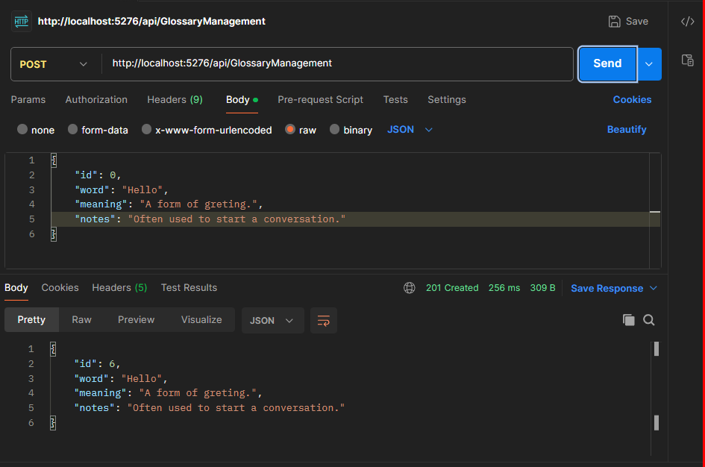

GET

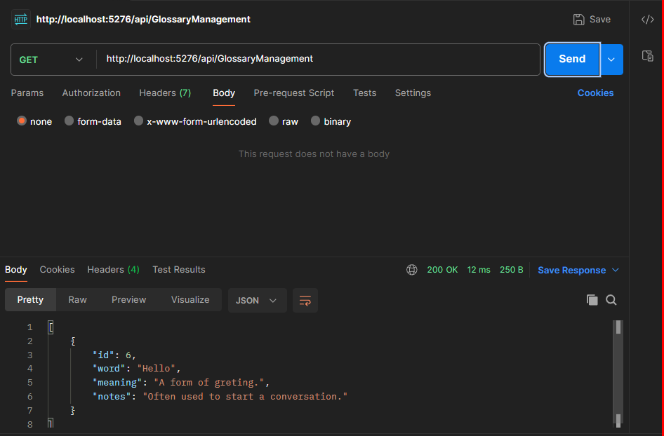

PUT

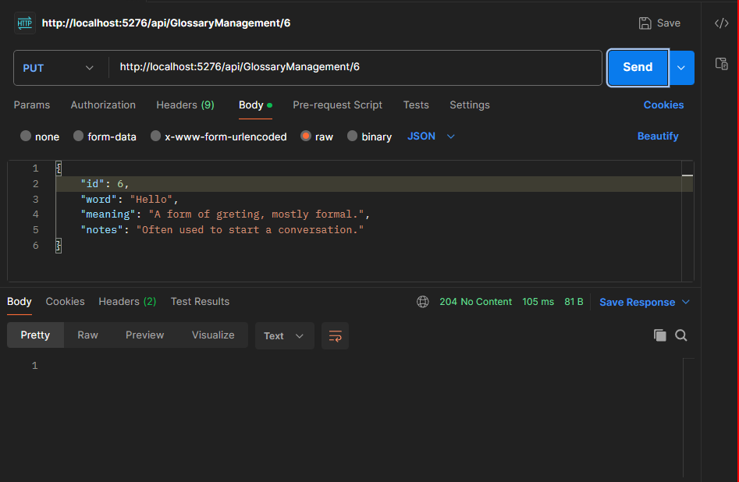

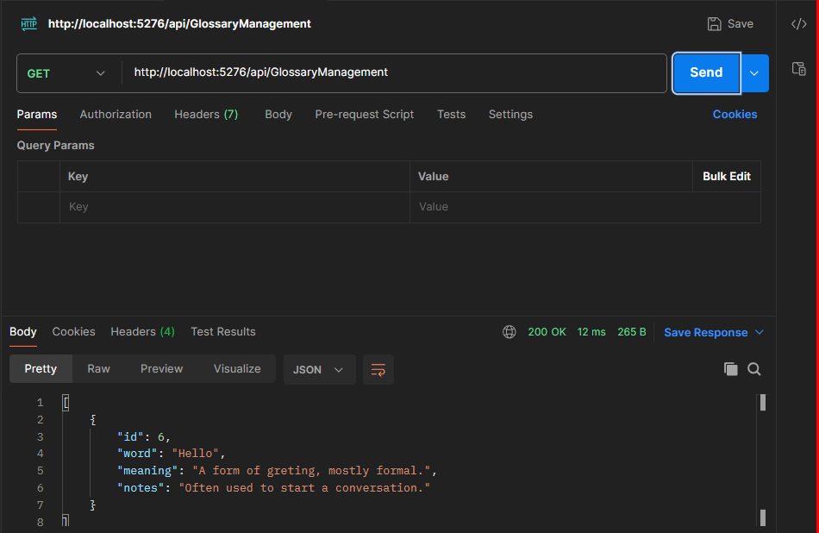
DELETE

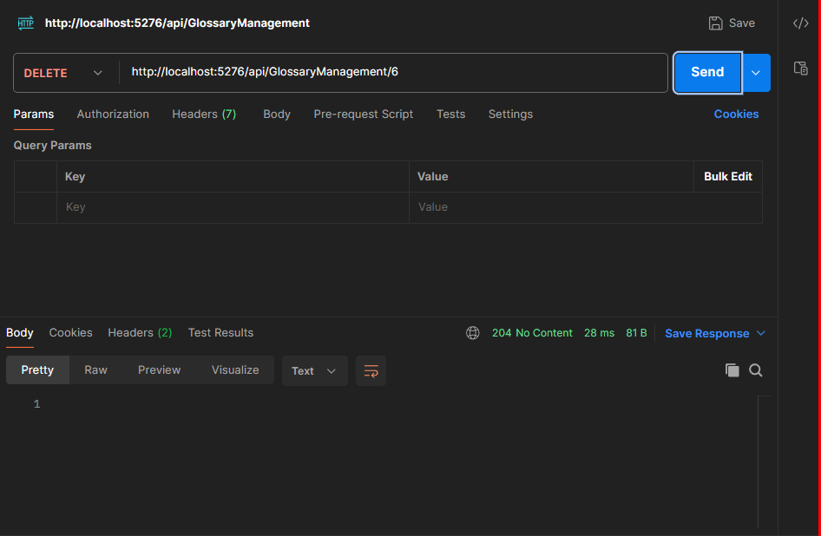

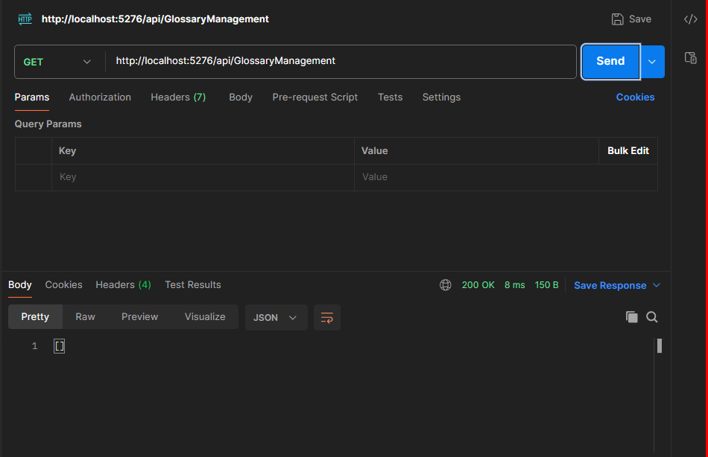
TranslationEngineService

POST

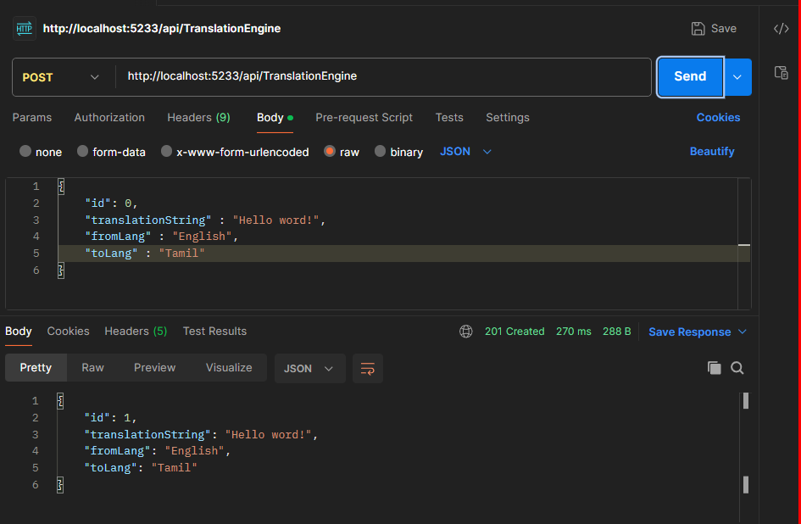

GET

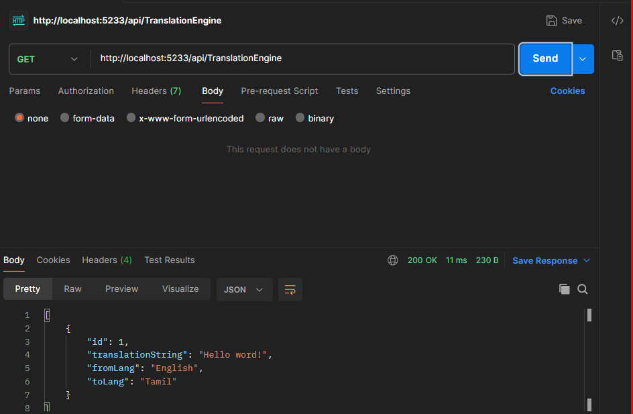
PUT

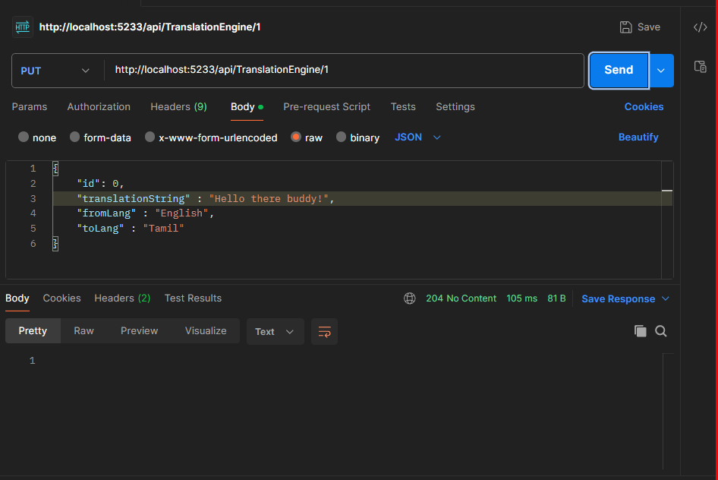

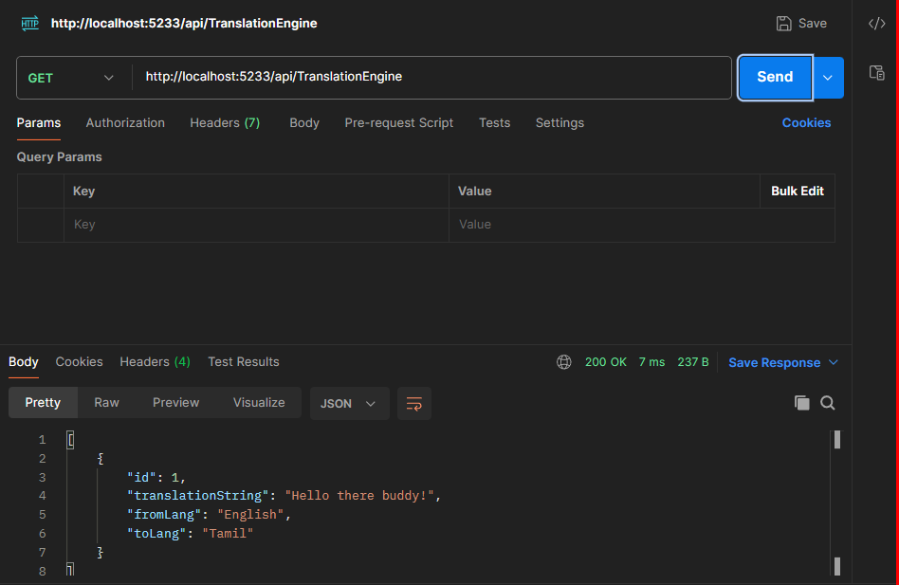
DELETE

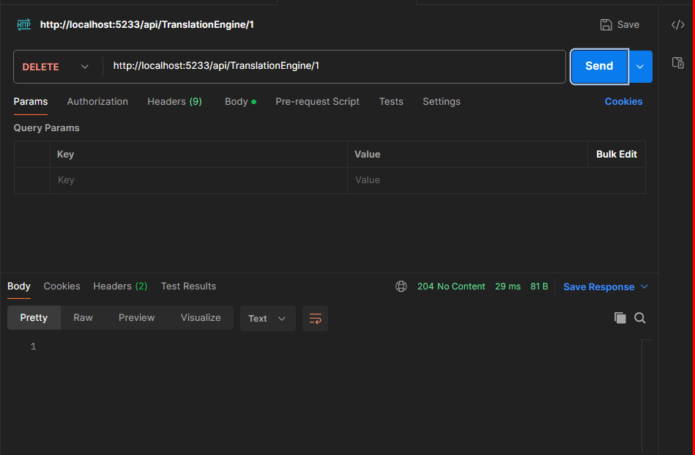

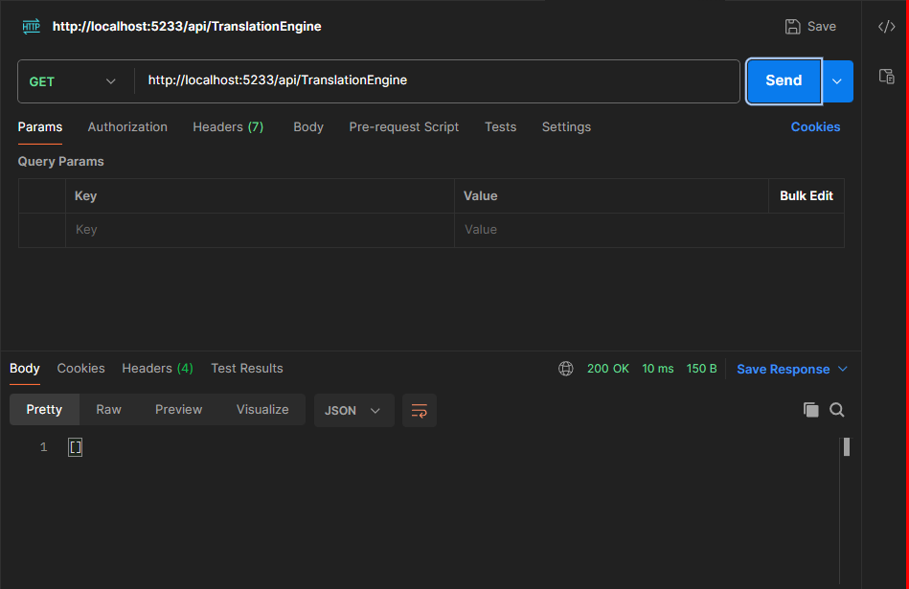
LanguageDetectionService

POST
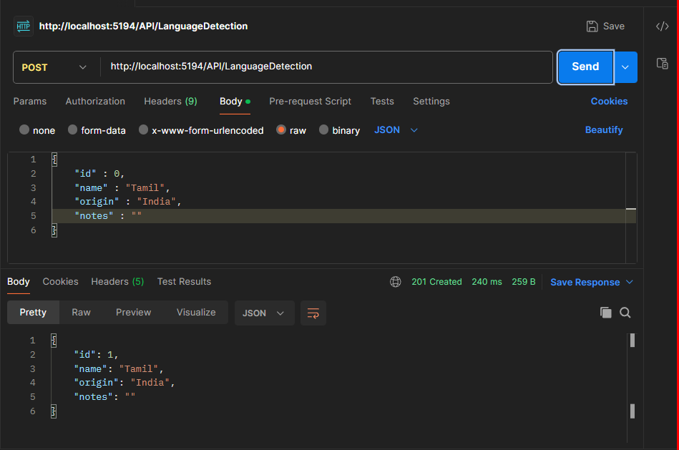
GET

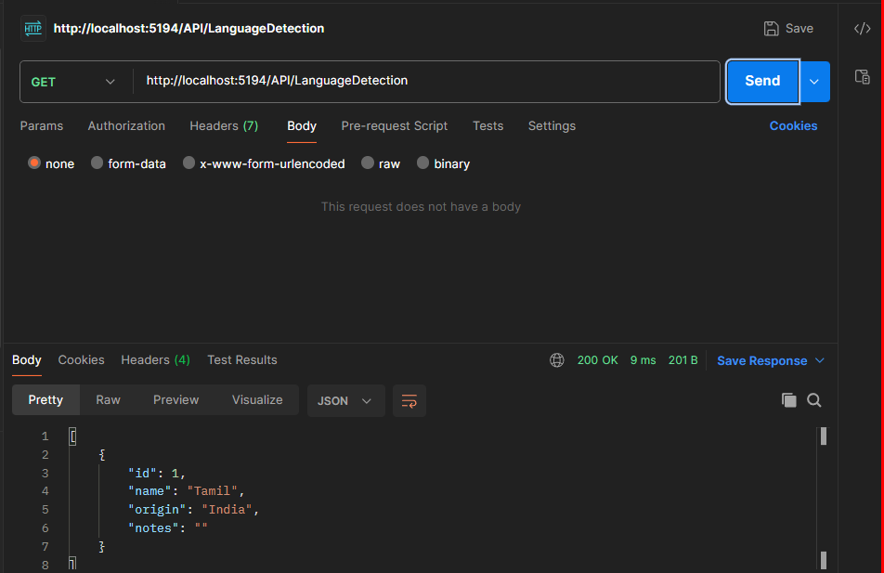
PUT

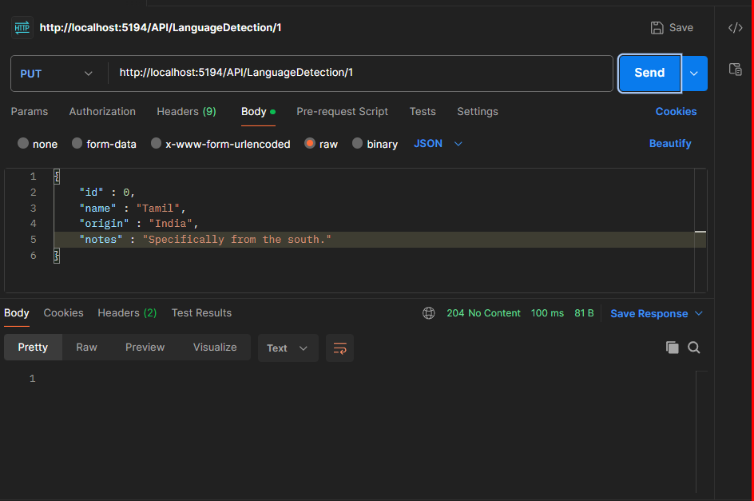

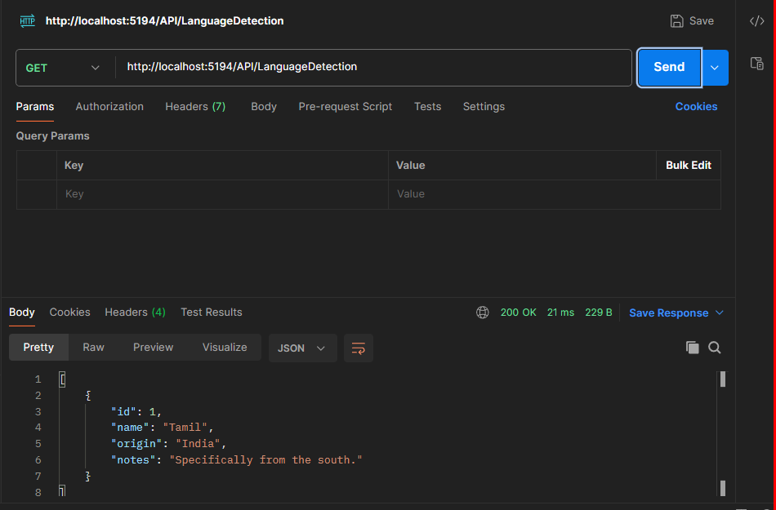
DELETE

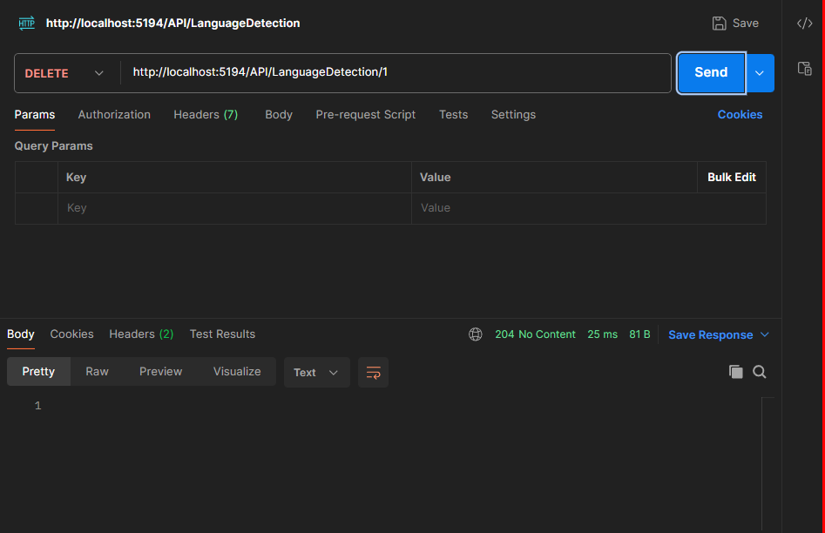

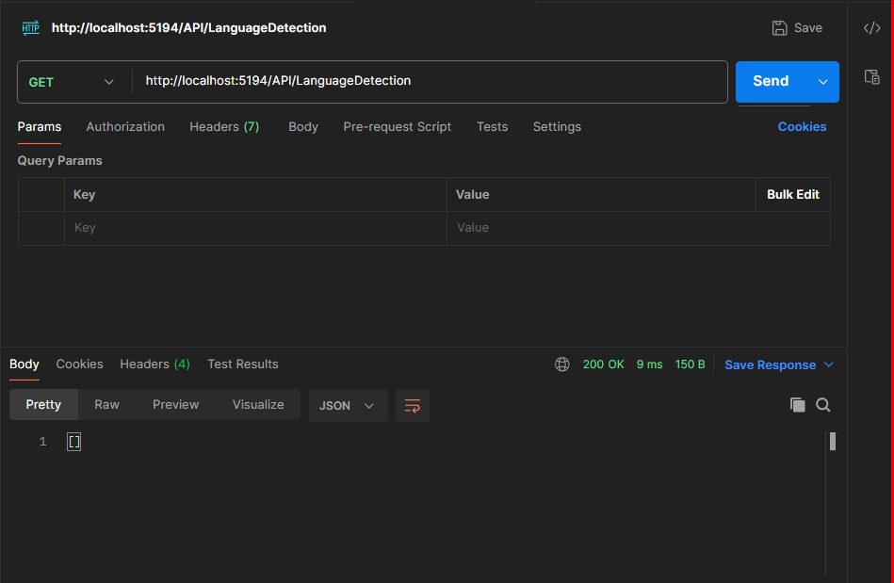
Front-End Outputs that utilizes the gateway

Home Page

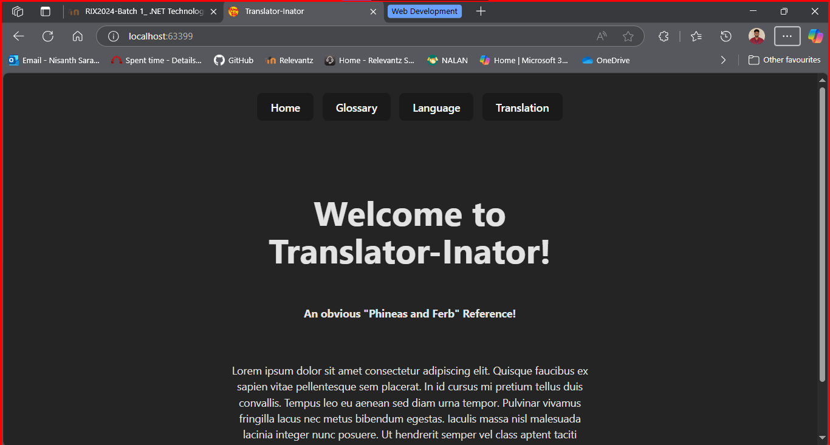
Glossary Manager

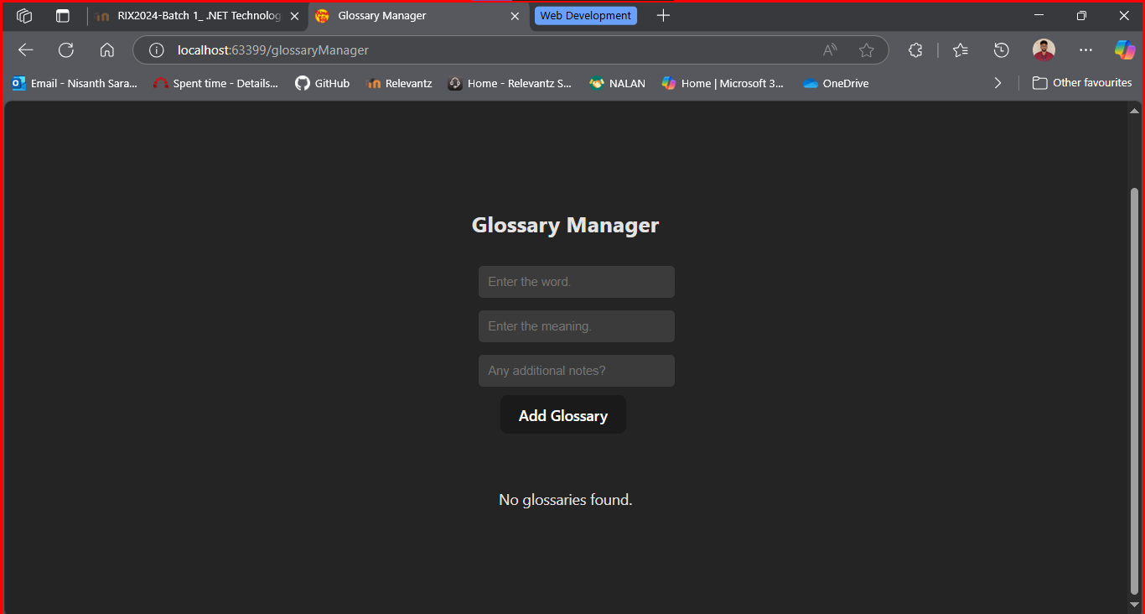




After adding…



With no notes provided, the “No Notes.” is inserted instead.

Editing

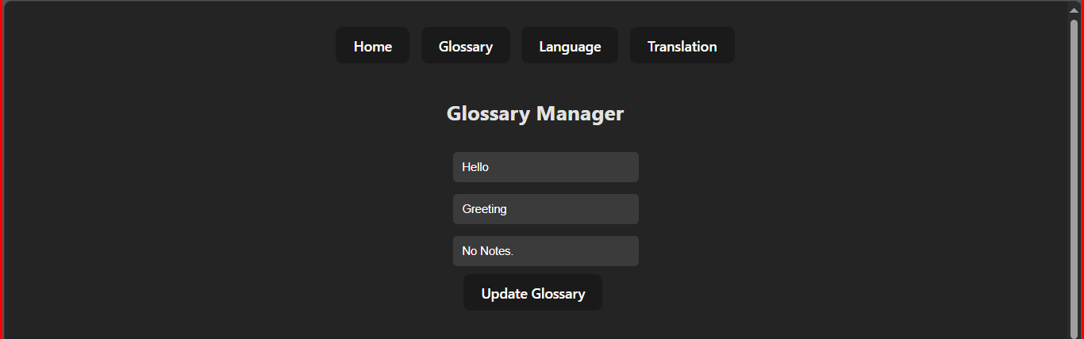




Searching



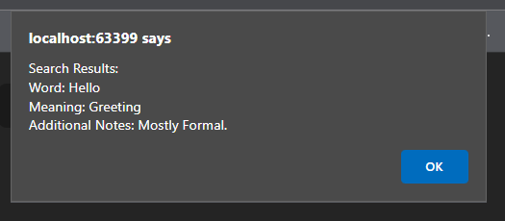

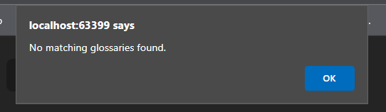

Deletion



Language Manager

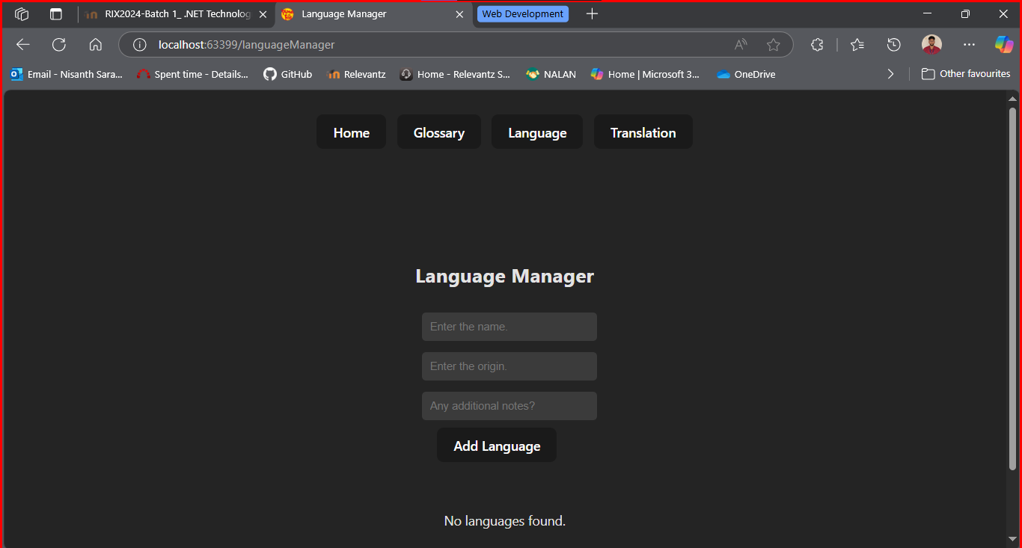





Meaning Origin and Notes can be null.
Editing





Searching

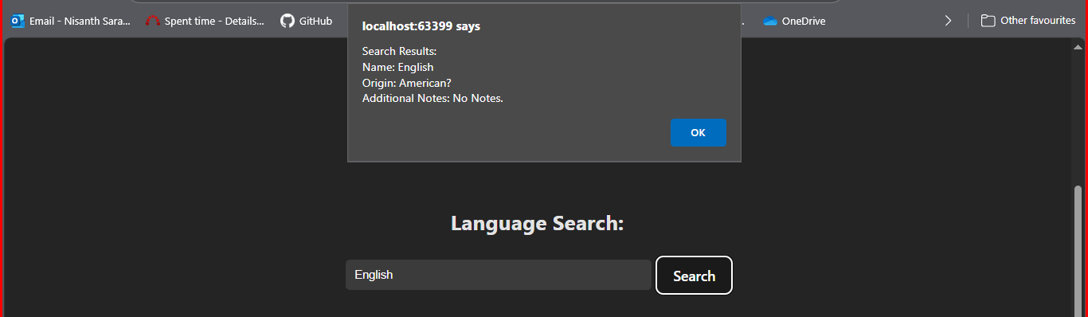

Deleting


Translation Manager

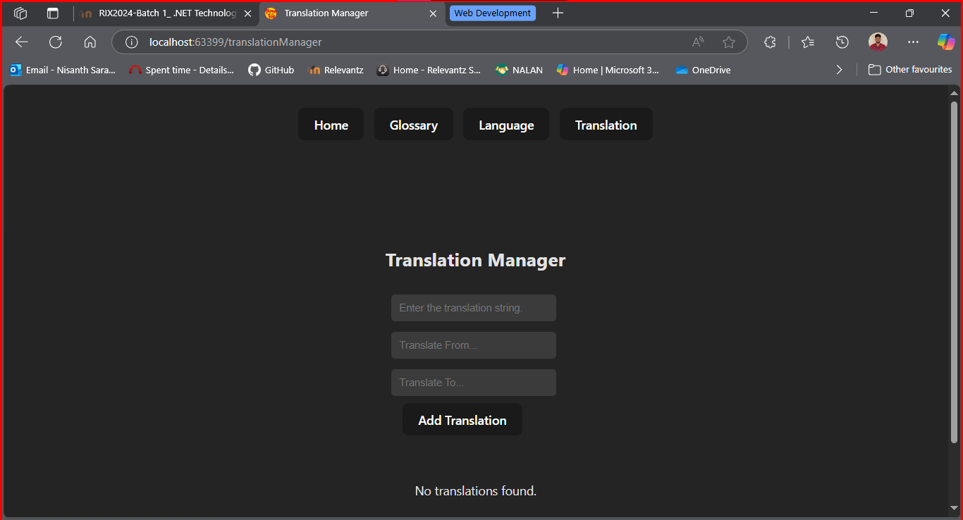






All the fields are required.
Editing





Searching

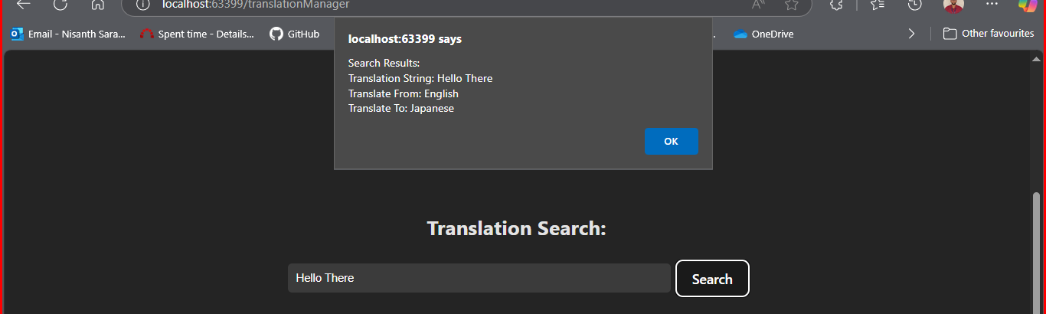

Deleting



****************************************************
F I N
****************************************************

